**16-BIT SUBTRACTION**  
  
  
**EXP NO: 6**

**AIM:**To  
write an assembly language program to implement 16-bit subtraction using 8085  
processor.  
  
**ALGORITHM:**  
1)   Start the  
program by loading a register pair with address of 1st number.  
  
2)     Copy the data to another register pair.  
  
3)      Load the second number to first registre pair.

4)     Subtract the two register pair contents.  
  
5)     Check for borrow.  
  
6)      Store the value of difference and borrow in memory  
locations.  
  
7)      End.  
  
**PROGRAM:**  
  
      LHLD  
2050  
  
  
      XCHG  
  
  
      LHLD  
2052  
  
  
      MVI C,00  
  
  
      MOV A, E  
  
  
      SUB L  
  
  
      STA 2054  
  
  
     MOV A, D  
  
  
      SUB H  
  
  
      STA 2055  
  
  
      HLT  
  
  
**INPUT:**  
  
  
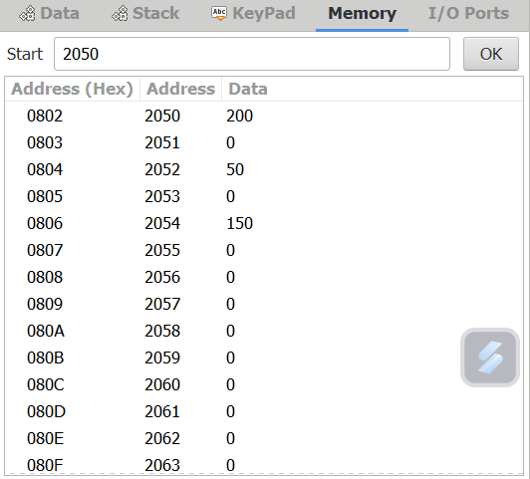

**OUTPUT:**

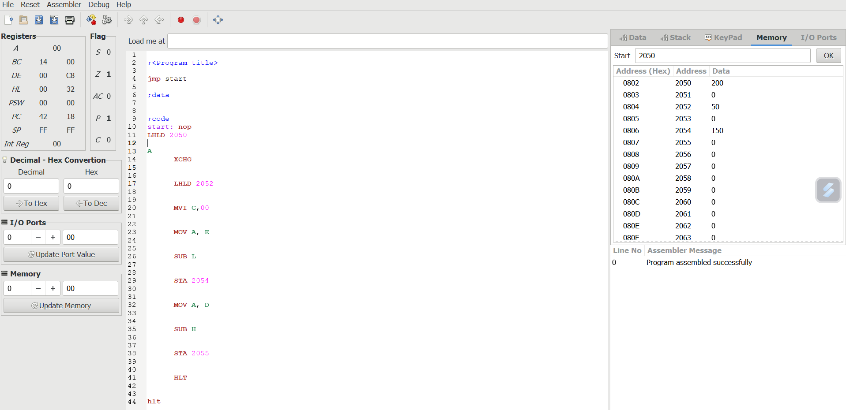  
  
  
  
  
  
  
  
  
  
  
**RESULT:**Thus the program was executed successfully using 8085  
processor simulator.